PANTHERS 2014-2015 FRESHMAN/JV MENS BASKETBALL SCHEDULE
Date | Opponent | Time & Place
Tuesday 11-18-14 | Furr | 4:30p.m., 6:00 p.m. @ Davis
Friday 11-21-14 | Milby | 4:30p.m., 6:00 p.m. @ Davis
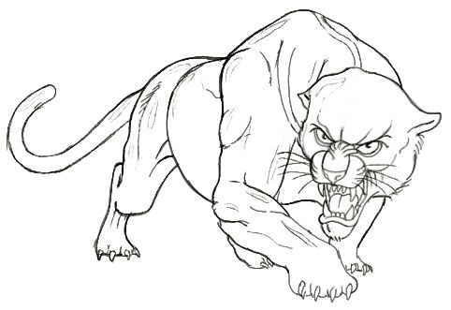  Fri-Sat Nov 28-29, 2014 | Sterling JV Tournament | TBA
Tuesday 12-2-14 | Ft. Bend Clements | 4:30p.m., 6:00 p.m.@ Clements
Thur-Sat Dec 4-6, 2014 | Scarborough Freshman Tournament | TBA
Friday 12-5-14 | Scarborough | 4:30pm,6:00pm@ Scarborough
Tuesday 12-9-14 | *Madison | 5:00 p.m., 6:00 p.m. @ Davis
Tuesday 1-6-15 | *Sharpstown | 5:00 p.m., 6:00 p.m. @ Davis
Friday 1-9-15 | *Yates | 5:00 p.m., 6:00 p.m. @ Yates
Tuesday 1-13-15 | *North Forest | 5:00 p.m., 6:00 p.m. @ Davis
Friday 1-16-15 | *Austin | 5:00 p.m., 6:00 p.m. @ Austin
Tuesday 1-20-15 | *Lee | 5:00 p.m., 6:00 p.m. @ Lee
Friday 1-23-15 | *Waltrip | 5:00 p.m., 6:00 p.m. @ Davis
Tuesday 1-27-15 | *Madison | 5:00 p.m., 6:00 p.m. @ Madison
Friday 1-30-15 | *Sharpstown | 5:00p.m.,6:00p.m.@Sharpstown
Tuesday 2-3-15 | *Yates | 5:00 p.m., 6:00 p.m. @ Davis
Friday 2-6-15 | *North Forest | 5:00 p.m., 6:00 p.m. @ NF
Tuesday 2-10-15 | *Austin | 5:00 p.m., 6:00 p.m. @ Davis
Friday 2-13-15 | *Lee | 5:00 p.m., 6:00 p.m. @ Davis
Tuesday 2-17-15 | *Waltrip | 5:00 p.m., 6:00 p.m. @ Waltrip

Head Coach: Louis Hernandez; Varsity Assistant: Christopher Moore; JV Coach: Bryan Shelton; Freshman Coach: Carl Wilson

